
Year 10
Pathway 2

End of Term 1 Test

Total Marks: 64 marks

Name: ______________________ Total Time: 55 minutes

Full working out must be shown to get full marks.
Attempt all questions

Resources allowed:
1 A4 page, (1 side) of hand written notes
Calculator

- Complete the following [7 Marks]
- Write $6 6 6$ in index notation

- Evaluate 210

- Simplify $x^{9}÷x^{3}$

- Simplify ${\left(y^{5}\right)}^{2}$

- Simplify $2w 7x w 5x$.

- Evaluate 2⁵

- Simplify $3^{5}×3$ (leaving your answer in index form)

2) Expand the following: (simplify when necessary) [1,1,2,2,marks]
a) 4(a + 3) b) 5x( x +3)

a) 2(a + 2) + 3(2a + 1) b) 4a(3 + 2a) – 2(a +b)

3) Find the equations of the straight lines in the following graphs. [3, 3 Marks]
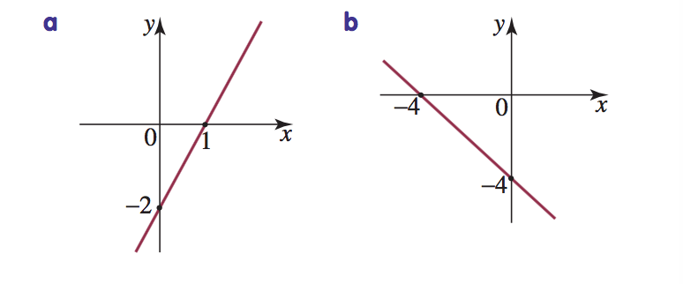

Gradient-
Y intercept-
Equation-
Gradient-
Y intercept-
Equation-

4) Calculate the surface area of the following Shapes. [ 3, 3, 3- Marks]
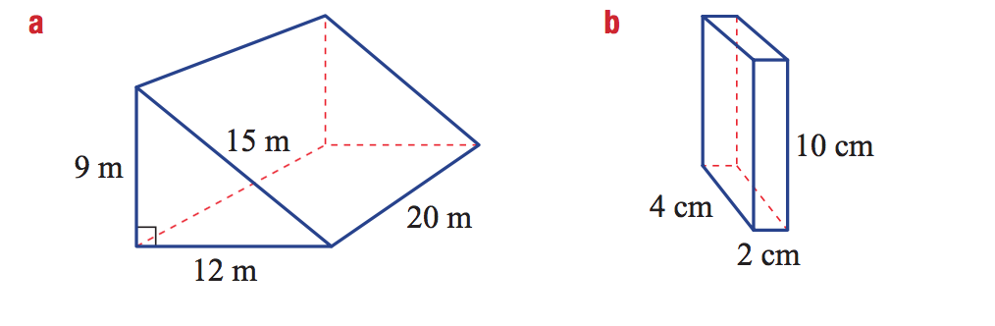

c)

17 cm

21 cm

5) Simplify the following algebraic fractions [1, 1, 2, 2, 2, 2-marks]
a) $\frac{4a}{2}$ b) $\frac{2a}{10}+\frac{5a}{10}$

c) $\frac{2c}{5}+\frac{4c}{10}$ d) $\frac{9z}{10}-\frac{3z}{5}$

e)$\frac{6b}{3} ×\frac{4b}{10}$ f) $\frac{5d}{6} ÷\frac{5d}{8}$

6) Simplify each of the following and express your answer with positive indices.
[2, 2-marks]

- 2a-5b2 x 4a-6b-4
- (2m-3n2)-4

7) Use the graphs below, showing the given simultaneous equations, to write the point of intersection of the graphs and, hence, the solution of the simultaneous equations. [2 marks]
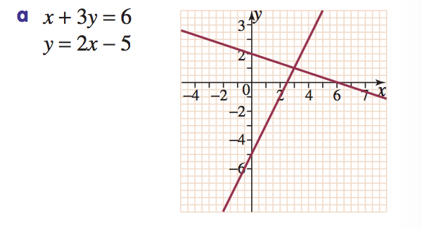

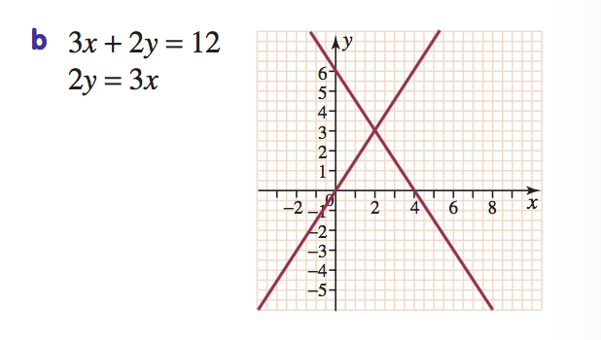

8) Find the x- and y-intercepts of the following straight lines. [2, 2, 2-marks]
a) y = -12x + 6 y int= x int=

b) y = $\frac{1}{2}$x - 5 y int= x int=

c) y = 2x - 3 y int= x int=

9) A fun park charges a $12.50 entry fee and an additional $2.50 per ride.
[3, 2, 1, 4, Marks]

- a) Complete the following table of values relating the total cost to the number of rides.
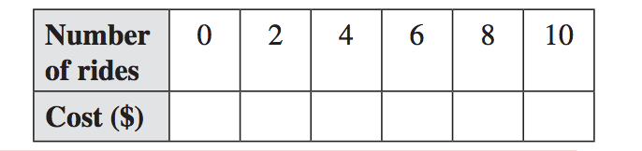
- b) Find a linear equation relating total cost to the number of rides.

c) Using algebra, calculate the cost for 7 rides.

- d) Sketch the linear equation on a Cartesian plane over a suitable domain.
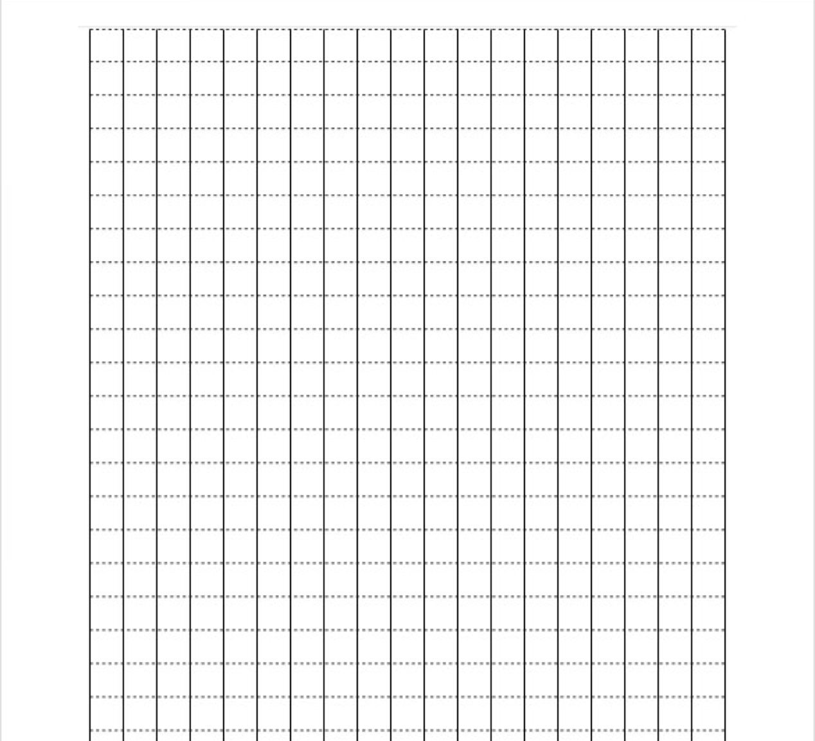

10) Calculate the surface area of the following composite shape [5 Marks]

- cm

9 cm

10.8 cm

8.5 cm
14 cm

End of Test

